Please advise which of our High Tech Security Products, that are if interest and we will send you a Detailed PowerPoint Presentation, the following are our recently introduced Products, advise interest:-

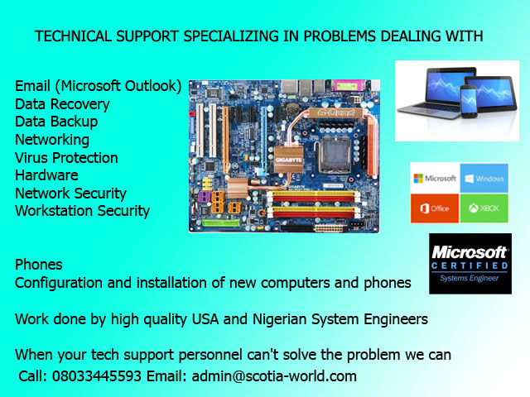
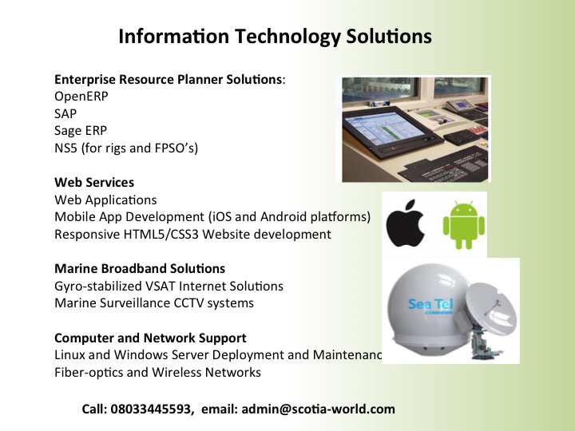

Track Company Vehicles / Fleets Management.
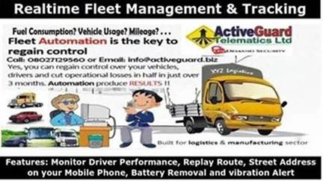
. Your Company Vehicles/fleets requires a more effective management
. You need to have a better understanding on the car usage status
. You want to have a better understanding on fuel consumption, usage and mileage driven
. You want to lower the management and maintenance cost
. You want to improve driver’s behaviour

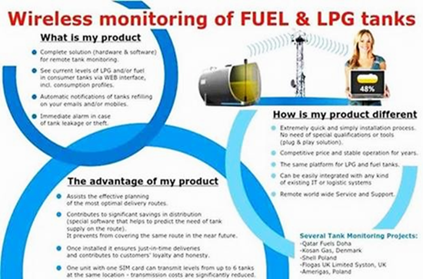

ACCESS CONTROL – Latest Technology.

In many environments, visitors are still asked to enter their information in a paper log book. While this method is perceived as quick and easy, it provides little security and leaves visitor information available for anyone to see. To address these issues, HID Global's EasyLobby® Secure Visitor Management solutions allow organizations to automate the entire process of registering a visitor, printing a badge and capturing detailed information in seconds by simply electronically scanning an ID (such as a driver's license, business card or passport).
The solution is flexible, customizable and feature-rich to meet the needs of small and enterprise organizations with diverse visitor management processes and policy requirements.

High Efficiency 100% Solar Powered Air Conditioner for Homes, Offices, Hotels, Schools, Restaurants, Churches etc.
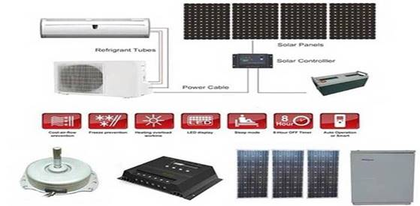
DC VFT Solution
In addition to avoiding the cost and power loss of an inverter, our system is engineered from the ground up for use with solar. Special electronics anticipate and smoothly handle voltage fluctuations of up to 38% without affecting the operation. In addition to the compressor and control circuits, all other electrical components are DC powered including high efficiency DC fan motors, DC valves & solenoids, etc. There are no inverters used inside the system.

Specifications
1.100% energy save by using pure solar power
2.no need any electricity
3.CE,ISO9001,CCC approved
12000BTU High Efficiency 48V DC air conditioner features:
Prolong Lifespan of Your Car, Inverter, and Batteries by up to 8 years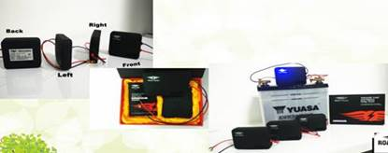
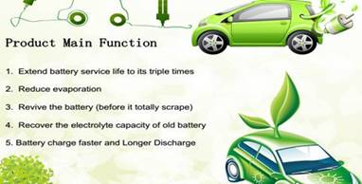

• Automotive batteries • Motorbike batteries • Marine, jetski batteries • Truck, RV batteries • Electric golf carts • Electric cars and scooters • Electric bicycles • Electric wheelchairs • Earthship / off-grid battery banks • UPS battery banks • DC systems of electrical substations • Telecommunication hubs • Wind farm storage systems • Solar farm storage systems • Back-up system battery banks • DC starting systems of generators
Intelligent CCTV and Video Monitoring Solutions
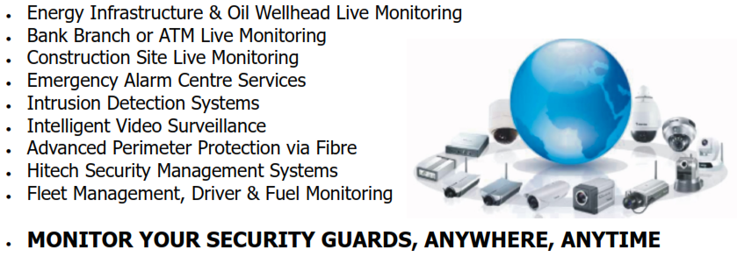

Long distance Camera for Various Security Surveillance:

Long Distance Camera - Optical
= Day : 6 ~ 25km Visible, Night : 4 ~ 15km visible =
~ Built-in PTZ Driver + Motorized Zoom Camera (100x, 60x, 22x) ~
- Video Server + Preset-Scan, Target-Scan Software (NVR) –-- IR illuminator, Laser illuminator --

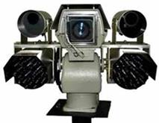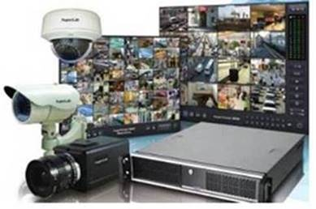

Fence Mounted Perimeter Intrusion Detector
~ Magnetic Cable Fencing Sensor : Secu Sensor ~
- Signal Analyzer, Terminal Box, Join Box, Gate Kit, Surge Protector : Local Parts - A
-- Data Interface, Audio Interface, E-Map S/W, Server : Center Parts --
= Fence Cut, Sensor Cable Cut, Climbing, etc. : Detection & Analyze =
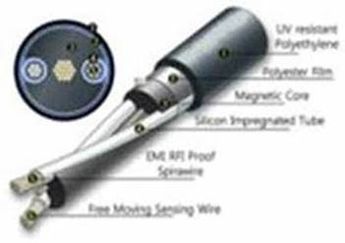 | 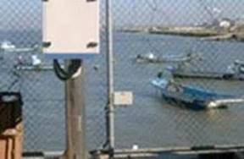
= Magnetic Cable Fencing Sensor Detection System =
Fence Mounted Perimeter Intrusion Detector
~ Magnetic Cable Fencing Sensor : Secu Sensor ~
- Signal Analyzer, Terminal Box, Join Box, Gate Kit, Surge Protector : Local Parts - A
-- Data Interface, Audio Interface, E-Map S/W, Server : Center Parts --
= Fence Cut, Sensor Cable Cut, Climbing, etc. : Detection & Analyze =

Military/Security Thermal Imaging Cameras
-- Long-wave Infrared Thermal Night Vision Camera : Military --
~ Resolution : 640x480, Lens : 8~100~250mm ~
-- Vehicle Detection : 8,462m with 100mm Lens --
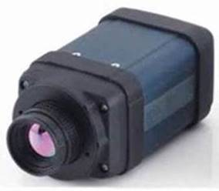 | 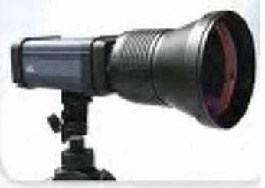
= Infra Red Thermal Imaging Cameras =

Monitor Your Diesel Supplies & Consumption Online. Over 41% Savings Achievable on Fuel cost.
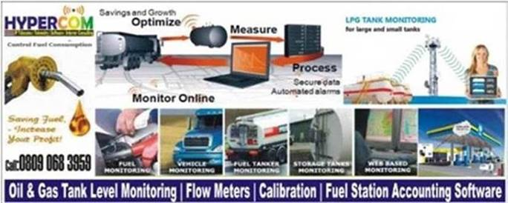
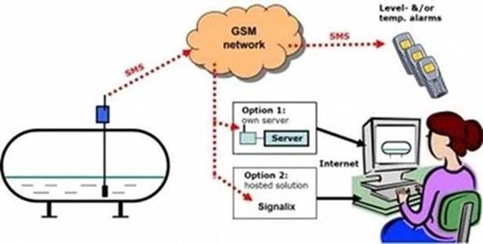

Monitor your Assets using a Padlock, which both tracks your asset (Container / Heavy Duty Machinery / Expensive Equipment ), but also advise when the Padlock is Opened, with 5 Text Messages / Emails to your senior staff.

Home/office Warehouse Digital Security Solutions
GAS LEAKAGE PROTECTION, SMART FIRE ALARMS & DETECTORS, BURGLAR ALARMS, WAREHOUSE SECURITY, HOME & OFFICE PROTECTION SYSTEMS
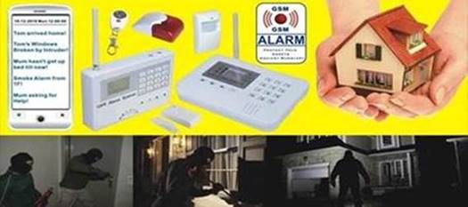
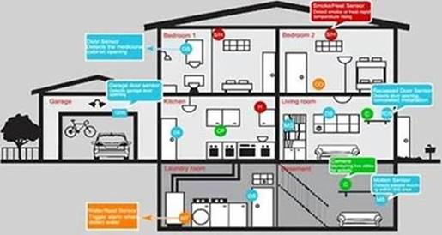

PORTABLE EXPLOSIVE DETECTORS
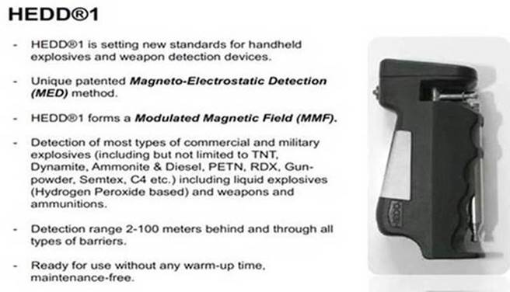
Security Command & Control Room Design & Development:
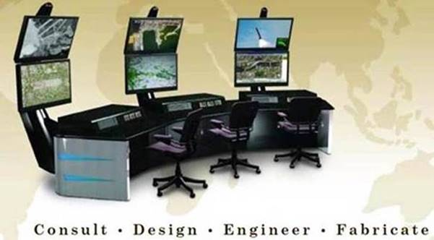

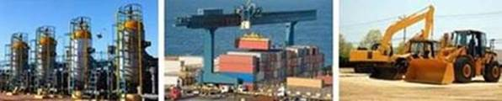

All The Best !!!
James Sharp.
Security - IT - Telecommunication Consultant.

LETS MAKE IT HAPPEN IN 2015 !!!

Scotia World Ltd.
Email :-james.sharp@scotia-world.com
jamessharp2004@yahoo.com
Tele :- 0044 141 416 0200 UK - International.

Scotia Nigeria Limited,
37 Bimkol Cres, GRA2,
Port Harcourt,
River State.
Nigeria.
Nigerian GSM +234 818 315 2433 Scotia Nigeria Ltd.
+234 703 284 5561 Scotia Nigeria Ltd.
+234 818 360 5335 Scotia Nigeria Ltd.
BBM - 2125D2F7
Skype Name jamesrambosharp

