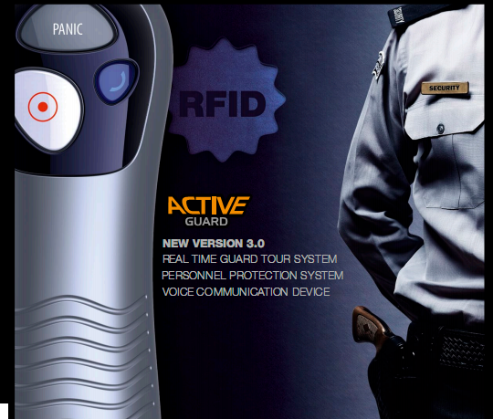

Realtime Guard Patrol & Security Management System

Via

ActiveGuard Virtual Alarm Response Network

(vARCnet) 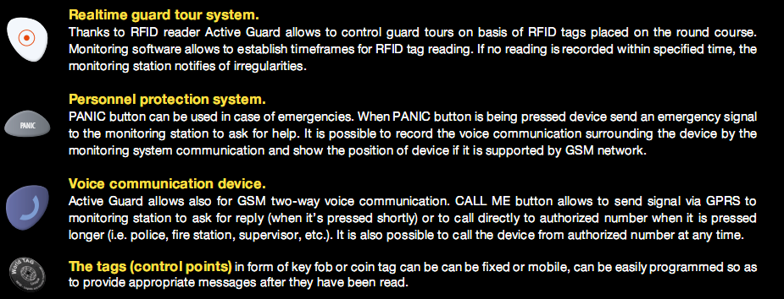

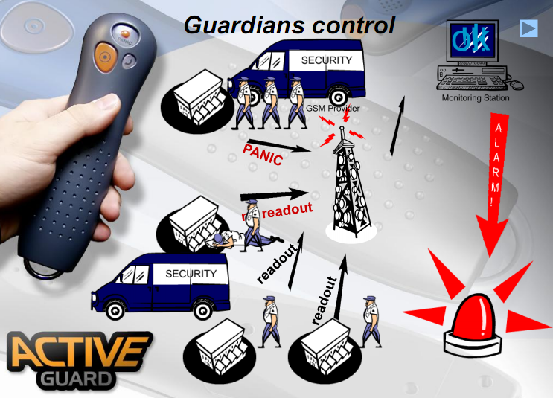

The first in the world real-time guard control system!
Active Guard is the most advanced, first of its kind in the world, system that makes it possible to monitor the time, place and results of the work of personnel in real time, thanks to the use of a GPRS-based data transmission technology.

Active Guard is also a voice connection with employees, possible without the need to equip them with additional devices, such as cellular phones or short-wave radios.
Active Guard is a system for notifying of situations requiring immediate reaction and assistance, replacing robbery notification devices.

Active Guard is the ability to locate an employee on the basis of markers placed on the round course. Monitoring software allows to establish timeframes for marker reading. If no reading is recorded within specified time, the monitoring station notifies of irregularities.
Designed for guard control, Active Guard is a highly flexible system and can be used also for other purposes, e.g. access control and identification, technical inspection monitoring, storage and rental systems monitoring, or maintenance systems.

Active Guard is a real revolution in security!

Functions:
- Remote configuration - comfortable maintenance and time saver
- Encryption of transmitted date - full safety of data transfer
- Increased event buffer capacity up to 1000 events - long lasting and easy device operation in areas with no GSM network coverage
- System event history - evidence up to 5000 events enabling to diagnose causes of possible problems
- Device status monitoring - diagnostic mode for person implementing system
- Registered battery lid opening event after main battery discharge - increased anti-sabotage security
- Increased sensitivity of RFID reader - better device usage comfort
- Circuit enabling testing if device was not exposed to strong electromagnetic field i.e microwave origin - lesser device breakdown, higher reliability due to increased anti-sabotage security
- Retransmission of incoming SMS - monitoring of transmission costs by retransmitting the SMS to operator about limit violation
- MAN-DOWN function - notification of threats to the life of the user
- Power down by button combination - feature enables to switch off device in designated areas without necessity of housing opening
- Modern, 4 band modem u-blox - secure GSM connection
- Comfortable programming/debugging socket - easy and quick way for full device configuration using computer and cable
- Capability of adding a Bluetooth module- possibility to expand system by extra accessories (headset, GPS module)
- New, more durable housing (silicone gaskets, more screws, additional shock absorbers)

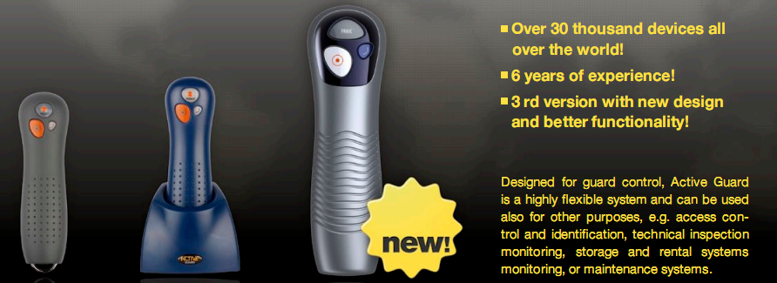

NEW better functionality and design
- Built-in accelerometer
Man-down detection – notification about life-threatening of the user life threat
Excessive shock detection – notification about attempt destroying the device
Tilt detection with configurable positions and angles – notification about changing the position of device – alarm signal if the position is outside the defined range
- Form optymalization
More comfortable in use and more durable
- Silicone gasket
Placed in special grooves in the housing - for better durability and tightness
- More main screws and screws on battery cover
Better distribution of forces at the fall
- Keyboard protected against strong press
- 6 shock and vibration absorption rings

Advantages:
- Savings in many areas: saving the time of control employees, saved time resulting from the obviation of programming equipment in the field and downloading its memory, saving on the means of communication of security guards with the operations centre, saving on the costs of anti-robbery systems, optimisation of the level of employment due to the control of performed duties.
- Instant irregularity warning.
- The ability to react immediately, which helps increase the safety and quality of work.
- A practically unlimited range of operation.
- Easily chosen and freely changeable in time number of readers and control points serviced.
- Multi-purpose Active Guard remotes - a recorder of actions performed, work time recorder, anti-robbery remote, a phone for communication with the operations centre of the firm.
- The ability to centralise the management, control and analysis, with free distribution of field services at the same time.
- The ability to quickly adjust the system to currently guarded premises, equipment maintained, etc.
- Saving the data even in the case of total destruction of the reader.
- Resistance to any kind of weather conditions (cold, moisture, heat).
- Safety for workers
- Resistant to destruction attempts

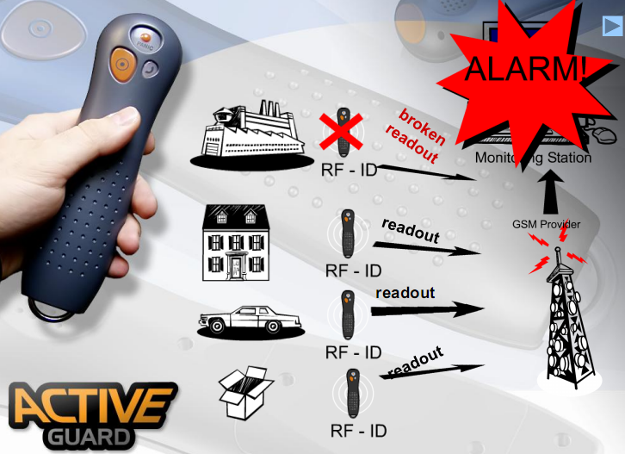
About ActiveGuard Telematics Ltd:
ActiveGuard Telematics Ltd is a leading, provider of integrated risk mitigation solutions to multinational corporations, governments, non-governmental organisations and private individuals. When it really matters clients turn to ActiveGuard, trusting us to protect their most valuable assets and to work alongside them on their highest risk projects. By integrating technology-based solutions in our overall service offerings to mitigate key risks, we achieve a multiplier effect for clients.

ActiveGuard 24/7 Point Zero
Software Data Sheet
An integrated operations Platform for Corporate Security Management

version: SECURITY
release: vsSEC1.0.1.13
device suitability: Android 2.3 and later (preferably with NFC capability)
vsSEC1.0.1.13 (KronosNET by Next! KronosStd protocol) February 2013

This software application, the intellectual property rights attached to it including any innovative concepts and methodologies revealed by it, it's derivatives and future enhancement rights, distribution rights, and its ownership is protected by international law.

Unregistered use or unauthorised copy, unauthorised distribution, dis assembly and/or replication, or imitation, of this application
is strictly prohibited.
Product Warranty: Activeguard Telematics Ltd offers a limited warranty as a customer support service to handle application programming errors and/or other software issues that may become apparent following any particular version release, and warrants that the application functions and signals will operate in accordance with product details published directly by Activeguard Telematics Ltd for the version and release concerned. The use of this application requires the use of services provided by other parties such as telecommunications providers, internet service providers, and monitoring service providers, resulting in the operational ability of this application being outside the control of Activeguard Telematics Ltd. The result and/or operational effectiveness of functions and signals operation is therefore excluded from this warranty.
The limit of any warranty claim is restricted to the provision of a free of charge upgrade release of the version concerned, as and when a new release becomes available. Warranty claims will only be accepted for consideration by Activeguard Telematics Ltd from the original purchaser within 28 days of purchase, any warranty claim must be in writing and include proof of purchase together with a full description of the problem experienced so that Activeguard may determine if the claim request is application related or if the problem is due to factors outside it's control. Warranty claims may be submitted by email to 2470.warranty@Activeguard.biz.
Activeguard Telematics Ltd warrants that should a specific application error in any particular version/release become known, a common error that may affect all users of that specific version/release, a free of charge upgrade/fix release will automatically be provided to the recorded email address of all original purchasers registered as using the release concerned.
Disclaimer: Activeguard Telematics Ltd does not grant any guarantee either expressed or implied, including but not limited to any understood guarantees in respect of the operational ability of this application and/or any warranty of fitness for a particular purpose. Activeguard reserves the right to amend this document, or withdraw it at any time without prior notice due to continuing product development and constant changes in software and telecommunications technology. Activeguard Telematics Ltd reserves the right to make modifications and changes to the application without prior notice in respect to any functions described in this document. Depending on the actual device in which this application is installed, and the user programming choices of that device and this application, there are various available functions. The use of this application requires the use of services provided by other parties such as telecommunications providers, internet service providers, and monitoring service providers, resulting in the operational ability of this application being outside the control of Activeguard Telematics Ltd. Under any circumstances Activeguard Telematics Ltd will not bear responsibility for any personal or commercial income loss or data loss, nor any personal injury or any other incidental, accidental or indirect damages caused in any way by the installation and/or the use and/or the removal of this application or subsequent upgrade/fix releases of this application.

Operational Overview
The 24/7 Point Zero application for the security industry has been designed for use by guards, patrol officers, response team members, duty inspectors, in fact any staff member in the field. This specific version is designed to interact with other versions, including direct message system and push to talk interoperability with clients using Corporate and/or Personal versions within the same ARC service group.
User activities are performed by double tap on the required feature screen icon, and subsequent entry of minimal detail depending on task.
The application streamlines operational activities, including reports and event logging, by providing direct connectivity between the duty officer and the ARC system, thereby speeding up the operational process, reducing workload on ARC operators, and removing the need for handwritten notes or log book entries for a variety of field events. Officer safety procedures are supported by Panic button ARC notification, regular check-in timer with reminder function including check-in overdue ARC notification, and incident location arrival record with safety timer and status report reminder function including overdue status report ARC notification.

24/7 Point Zero may be used in various operational scenarios, including -
integrated alarm response services
duty officer management
guard / patrol tour system
24/7 Point Zero features include direct data connection with Alarm Receiving Center management systems and live interaction with duty operators, event record logging direct to client history files, time selectable GPS location reporting whilst on duty, guard tour location tag reporting direct to ARC when used on NFC equipped devices (with automatic reminder alert for missed points) direct messaging system, and PTT (push to talk) interface.
GPS location reports can also be sent direct to external OpenGTS tracking systems if required, these reports provide security companies with the ability to independently monitor staff transit activities at any time without reference to the ARC.
User privacy is assured whilst off duty, GPS location reports and other functions are disabled - with only the Panic button and direct messaging features in permanent operation.

Device Signals Capability
to ARC - alarm data protocol
Device Power Up: Date/Time, Device ID, GPS Position, Mobile Number or IMEI
Device Low Battery: Date/Time, Device ID, GPS Position
On Duty: Date/Time, User ID, GPS Position, Duty Task ID commenced
Off Duty: Date/Time, User ID, GPS Position, Duty Task ID ceased
Routine Check In: Date/Time, User ID, GPS Position, Duty Task ID
Overdue Routine Check In Report: Date/Time, User ID, GPS Position, Duty Task ID
Panic Alarm: Date/Time, User ID*, GPS Position, Duty Task ID* (*Device ID only if Off Duty)
Man Down Alarm: Date/Time, User ID, GPS Position, Duty Task ID (optional use)
Response In Progress: Date/Time, User ID, GPS Position, Duty Task ID, Location ID
Arrived at Response Location: Date/Time, User ID, GPS Position, Duty Task ID, Location ID
Overdue Response Report: Date/Time, User ID, GPS Position, Duty Task ID, Location ID
No Further Action Required (All Clear): Date/Time, User ID*, GPS Position, Duty Task ID*, Location ID (*Device ID only if Off Duty)
Management / Police Required: Date/Time, User ID, GPS Position, Duty Task ID, Location ID
Log Entry: Date/Time, User ID, GPS Position, Duty Task ID, Location ID, report content by user
Guard Tour: Date/Time, User ID, GPS Position, Duty Task ID, Location ID, Tag ID (NFC equipped devices)

to ARC - internal message group
Message: User ID, message content by user
from ARC - SMS and/or internal message group
Alarm Attend / Job Dispatch: Date/Time, Location ID, Description, Location GPS Position if available
Overdue Guard Tour Visit Alert: Date/Time, Duty Task ID, Location Tag Description
Initiate Current Position Report back to ARC via alarm data protocol (codephrase required)
User to User - internal message group
Message: User ID, message content by user
to nominated OpenGTS server - OpenGTS data protocol (optional user setting)
Position Report: Date/Time, User ID, GPS Position
to nominated mobile number - SMS (optional user setting)
Panic Alarm: Date/Time, User ID, GPS Position, Duty Task ID, (User ID if Off Duty) fixed message content
Man Down Alarm: Date/Time, User ID, GPS Position, Duty Task ID, (User ID if Off Duty) fixed message content
from nominated (fixed/mobile) number - voice call (optional user setting)
Auto Answer / Communicate / Listen-In

from any mobile number - SMS
Message: Mobile ID, coded prefix message content by sender
Initiate Current Position Report by discreet SMS reply to senders number (codephrase required)

Operational Use

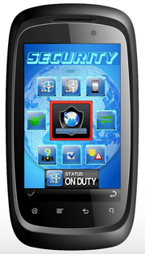
24/7 Point Zero Notifications -

Tones

This application has 6 distinct tones to notify of actions taken, actions required, and/or incoming alerts & messages
(these tones cannot be changed by the user, refer to application settings for volume control)

1. Error tone - examples, a single or incorrect icon tap / an icon action attempt when off duty
2. Reminder tone - examples, a Regular Check-In report is overdue / a response situation report is overdue
3. Incoming message tone - examples, an alarm reponse request is received / a message from another user is received
4. ARC signal acknowledge tone - examples, On Duty signal report received by the ARC system / Regular Check-In signal report received by the ARC system
5. Outgoing message acknowledge tone - examples, a Send Report message received by the ARC system / an outgoing user message is processed by the server
6. ARC Guard Tour tone - example, a tag read report received by the ARC system

CAUTION! ARC outgoing signal tone (4), outgoing message tone (5), and outgoing ARC guard tour report tone (6) only sound AFTER the data has been received by the netwrok server concerned. if you do not hear a confirmation tone when actioning this type of activity it is an indication of a data communication problem. check your device data service connection.

Signals buffer (during data service connection loss)

24/7 Point Zero has a built in outgoing signal buffer in case of data service connection failure. If your connection does fail, several hundred ARC activity signals may be stored for later sending. Direct messages are not buffered, if there is no data connection the user message send will fail and the message will need to be entered and sent when the data connection is restored. If your ARC signals are being buffered a message will be displayed at the top of the main application screen, the message will show the number of signals currently in buffer awaiting data service restoral.

CAUTION! Operating 24/7 Point Zero without a current data connection is not recommended. Although ARC signals will be stored and sent later, ARC systems in some countries are required by standards to reject signals with non current time & date stamp record in the signal concerned. It is also important to note that direct dispatch alarm response requests will not be received until after the data connection has been restored. Users with a data service connection failure should contact their ARC and make alternative communication arrangments until the device data connection has been restored.

New Message indication icon

Incoming messages, and action required reminders, are also indicated by a 24/7 Point Zero icon appearing in the notification bar at the top left of the main application screen.

GPS position information
Current GPS Position in device memory is displayed on the main application screen, just above the top row of icons.

Error Messages
Several
24/7 Point Zero Notifications -

Tones

This application has 6 distinct tones to notify of actions taken, actions required, and/or incoming alerts & messages
(these tones cannot be changed by the user, refer to application settings for volume control)

1. Error tone - examples, a single or incorrect icon tap / an icon action attempt when off duty
2. Reminder tone - examples, a Regular Check-In report is overdue / a response situation report is overdue
3. Incoming message tone - examples, an alarm reponse request is received / a message from another user is received
4. ARC signal acknowledge tone - examples, On Duty signal report received by the ARC system / Regular Check-In signal report received by the ARC system
5. Outgoing message acknowledge tone - examples, a Send Report message received by the ARC system / an outgoing user message is processed by the server
6. ARC Guard Tour tone - example, a tag read report received by the ARC system

CAUTION! ARC outgoing signal tone (4), outgoing message tone (5), and outgoing ARC guard tour report tone (6) only sound AFTER the data has been received by the netwrok server concerned. if you do not hear a confirmation tone when actioning this type of activity it is an indication of a data communication problem. check your device data service connection.

Signals buffer (during data service connection loss)

24/7 Point Zero has a built in outgoing signal buffer in case of data service connection failure. If your connection does fail, several hundred ARC activity signals may be stored for later sending. Direct messages are not buffered, if there is no data connection the user message send will fail and the message will need to be entered and sent when the data connection is restored. If your ARC signals are being buffered a message will be displayed at the top of the main application screen, the message will show the number of signals currently in buffer awaiting data service restoral.

CAUTION! Operating 24/7 Point Zero without a current data connection is not recommended. Although ARC signals will be stored and sent later, ARC systems in some countries are required by standards to reject signals with non current time & date stamp record in the signal concerned. It is also important to note that direct dispatch alarm response requests will not be received until after the data connection has been restored. Users with a data service connection failure should contact their ARC and make alternative communication arrangments until the device data connection has been restored.

New Message indication icon

Incoming messages, and action required reminders, are also indicated by a 24/7 Point Zero icon appearing in the notification bar at the top left of the main application screen.

GPS position information
Current GPS Position in device memory is displayed on the main application screen, just above the top row of icons.

Error Messages
Several
24/7 Point Zero Notifications -

Tones

This application has 6 distinct tones to notify of actions taken, actions required, and/or incoming alerts & messages
(these tones cannot be changed by the user, refer to application settings for volume control)

1. Error tone - examples, a single or incorrect icon tap / an icon action attempt when off duty
2. Reminder tone - examples, a Regular Check-In report is overdue / a response situation report is overdue
3. Incoming message tone - examples, an alarm reponse request is received / a message from another user is received
4. ARC signal acknowledge tone - examples, On Duty signal report received by the ARC system / Regular Check-In signal report received by the ARC system
5. Outgoing message acknowledge tone - examples, a Send Report message received by the ARC system / an outgoing user message is processed by the server
6. ARC Guard Tour tone - example, a tag read report received by the ARC system

CAUTION! ARC outgoing signal tone (4), outgoing message tone (5), and outgoing ARC guard tour report tone (6) only sound AFTER the data has been received by the netwrok server concerned. if you do not hear a confirmation tone when actioning this type of activity it is an indication of a data communication problem. check your device data service connection.

Signals buffer (during data service connection loss)

24/7 Point Zero has a built in outgoing signal buffer in case of data service connection failure. If your connection does fail, several hundred ARC activity signals may be stored for later sending. Direct messages are not buffered, if there is no data connection the user message send will fail and the message will need to be entered and sent when the data connection is restored. If your ARC signals are being buffered a message will be displayed at the top of the main application screen, the message will show the number of signals currently in buffer awaiting data service restoral.

CAUTION! Operating 24/7 Point Zero without a current data connection is not recommended. Although ARC signals will be stored and sent later, ARC systems in some countries are required by standards to reject signals with non current time & date stamp record in the signal concerned. It is also important to note that direct dispatch alarm response requests will not be received until after the data connection has been restored. Users with a data service connection failure should contact their ARC and make alternative communication arrangments until the device data connection has been restored.

New Message indication icon

Incoming messages, and action required reminders, are also indicated by a 24/7 Point Zero icon appearing in the notification bar at the top left of the main application screen.

GPS position information
Current GPS Position in device memory is displayed on the main application screen, just above the top row of icons.

Error Messages
Several
24/7 Point Zero Notifications -

Tones

This application has 6 distinct tones to notify of actions taken, actions required, and/or incoming alerts & messages
(these tones cannot be changed by the user, refer to application settings for volume control)

1. Error tone - examples, a single or incorrect icon tap / an icon action attempt when off duty
2. Reminder tone - examples, a Regular Check-In report is overdue / a response situation report is overdue
3. Incoming message tone - examples, an alarm reponse request is received / a message from another user is received
4. ARC signal acknowledge tone - examples, On Duty signal report received by the ARC system / Regular Check-In signal report received by the ARC system
5. Outgoing message acknowledge tone - examples, a Send Report message received by the ARC system / an outgoing user message is processed by the server
6. ARC Guard Tour tone - example, a tag read report received by the ARC system

CAUTION! ARC outgoing signal tone (4), outgoing message tone (5), and outgoing ARC guard tour report tone (6) only sound AFTER the data has been received by the netwrok server concerned. if you do not hear a confirmation tone when actioning this type of activity it is an indication of a data communication problem. check your device data service connection.

Signals buffer (during data service connection loss)

24/7 Point Zero has a built in outgoing signal buffer in case of data service connection failure. If your connection does fail, several hundred ARC activity signals may be stored for later sending. Direct messages are not buffered, if there is no data connection the user message send will fail and the message will need to be entered and sent when the data connection is restored. If your ARC signals are being buffered a message will be displayed at the top of the main application screen, the message will show the number of signals currently in buffer awaiting data service restoral.

CAUTION! Operating 24/7 Point Zero without a current data connection is not recommended. Although ARC signals will be stored and sent later, ARC systems in some countries are required by standards to reject signals with non current time & date stamp record in the signal concerned. It is also important to note that direct dispatch alarm response requests will not be received until after the data connection has been restored. Users with a data service connection failure should contact their ARC and make alternative communication arrangments until the device data connection has been restored.

New Message indication icon

Incoming messages, and action required reminders, are also indicated by a 24/7 Point Zero icon appearing in the notification bar at the top left of the main application screen.

GPS position information
Current GPS Position in device memory is displayed on the main application screen, just above the top row of icons.

Error Messages
Several
24/7 Point Zero Notifications -

Tones

This application has 6 distinct tones to notify of actions taken, actions required, and/or incoming alerts & messages
(these tones cannot be changed by the user, refer to application settings for volume control)

1. Error tone - examples, a single or incorrect icon tap / an icon action attempt when off duty
2. Reminder tone - examples, a Regular Check-In report is overdue / a response situation report is overdue
3. Incoming message tone - examples, an alarm reponse request is received / a message from another user is received
4. ARC signal acknowledge tone - examples, On Duty signal report received by the ARC system / Regular Check-In signal report received by the ARC system
5. Outgoing message acknowledge tone - examples, a Send Report message received by the ARC system / an outgoing user message is processed by the server
6. ARC Guard Tour tone - example, a tag read report received by the ARC system

CAUTION! ARC outgoing signal tone (4), outgoing message tone (5), and outgoing ARC guard tour report tone (6) only sound AFTER the data has been received by the netwrok server concerned. if you do not hear a confirmation tone when actioning this type of activity it is an indication of a data communication problem. check your device data service connection.

Signals buffer (during data service connection loss)

24/7 Point Zero has a built in outgoing signal buffer in case of data service connection failure. If your connection does fail, several hundred ARC activity signals may be stored for later sending. Direct messages are not buffered, if there is no data connection the user message send will fail and the message will need to be entered and sent when the data connection is restored. If your ARC signals are being buffered a message will be displayed at the top of the main application screen, the message will show the number of signals currently in buffer awaiting data service restoral.

CAUTION! Operating 24/7 Point Zero without a current data connection is not recommended. Although ARC signals will be stored and sent later, ARC systems in some countries are required by standards to reject signals with non current time & date stamp record in the signal concerned. It is also important to note that direct dispatch alarm response requests will not be received until after the data connection has been restored. Users with a data service connection failure should contact their ARC and make alternative communication arrangments until the device data connection has been restored.

New Message indication icon

Incoming messages, and action required reminders, are also indicated by a 24/7 Point Zero icon appearing in the notification bar at the top left of the main application screen.

GPS position information
Current GPS Position in device memory is displayed on the main application screen, just above the top row of icons.

Error Messages
Several
24/7 Point Zero Notifications -
Tones
This application has 6 distinct tones to notify of actions taken, actions required, and/or incoming alerts & messages
(these tones cannot be changed by the user, refer to application settings for volume control)
1. Error tone - a single or incorrect icon tap / an icon action attempt when off duty
2. Reminder tone - a Regular Check-In report is overdue / a response situation report is overdue
3. Incoming message tone - an alarm response request is received / a message from another user is received
4. ARC signal acknowledge tone - e.g. On Duty signal report received by the ARC system / Regular Check-In signal report received by the ARC system
5. Outgoing message acknowledge tone - a Send Report message received by the ARC system / an outgoing user message is processed by the server
6. ARC Guard Tour tone - a tag read report received by the ARC system
CAUTION! ARC outgoing signal tone (4), outgoing message tone (5), and outgoing ARC guard tour report tone (6) only sound AFTER the data has been received by the network server concerned. if you do not hear a confirmation tone when actioning this type of activity it is an indication of a data communication problem. check your device data service connection.
Signals buffer (during data service connection loss)
24/7 Point Zero has a built in outgoing signal buffer in case of data service connection failure. If your connection does fail, several hundred ARC activity signals may be stored for later sending. Direct messages are not buffered, if there is no data connection the user message send will fail and the message will need to be entered and sent when the data connection is restored. If your ARC signals are being buffered a message will be displayed at the top of the main application screen, the message will show the number of signals currently in buffer awaiting data service restoral.
CAUTION! Operating 24/7 Point Zero without a current data connection is not recommended. Although ARC signals will be stored and sent later, ARC systems in some countries are required by standards to reject signals with non current time & date stamp record in the signal concerned. It is also important to note that direct dispatch alarm response requests will not be received until after the data connection has been restored. Users with a data service connection failure should contact their ARC and make alternative communication arrangments until the device data connection has been restored.
New Message indication icon
Incoming messages, and action required reminders, are also indicated by a 24/7 Point Zero icon appearing in the notification bar at the top left of the main application screen.
GPS position information
Current GPS Position in device memory is displayed on the main application screen, just above the top row of icons.
Error Messages
Error tone - a single or incorrect icon tap / an icon action attempt when off duty (try again)
Signal buffer message appears - on main screen, above Security indicates data connectivity problem (check service)
24/7 Point Zero application crash message - indicates data connectivity problem on device power up, or application software problem (restart device)
Reminder tone Incoming Response / Message tone
24/7 Point Zero Notifications -

Tones

This application has 6 distinct tones to notify of actions taken, actions required, and/or incoming alerts & messages
(these tones cannot be changed by the user, refer to application settings for volume control)

1. Error tone - examples, a single or incorrect icon tap / an icon action attempt when off duty
2. Reminder tone - examples, a Regular Check-In report is overdue / a response situation report is overdue
3. Incoming message tone - examples, an alarm reponse request is received / a message from another user is received
4. ARC signal acknowledge tone - examples, On Duty signal report received by the ARC system / Regular Check-In signal report received by the ARC system
5. Outgoing message acknowledge tone - examples, a Send Report message received by the ARC system / an outgoing user message is processed by the server
6. ARC Guard Tour tone - example, a tag read report received by the ARC system

CAUTION! ARC outgoing signal tone (4), outgoing message tone (5), and outgoing ARC guard tour report tone (6) only sound AFTER the data has been received by the netwrok server concerned. if you do not hear a confirmation tone when actioning this type of activity it is an indication of a data communication problem. check your device data service connection.

Signals buffer (during data service connection loss)

24/7 Point Zero has a built in outgoing signal buffer in case of data service connection failure. If your connection does fail, several hundred ARC activity signals may be stored for later sending. Direct messages are not buffered, if there is no data connection the user message send will fail and the message will need to be entered and sent when the data connection is restored. If your ARC signals are being buffered a message will be displayed at the top of the main application screen, the message will show the number of signals currently in buffer awaiting data service restoral.

CAUTION! Operating 24/7 Point Zero without a current data connection is not recommended. Although ARC signals will be stored and sent later, ARC systems in some countries are required by standards to reject signals with non current time & date stamp record in the signal concerned. It is also important to note that direct dispatch alarm response requests will not be received until after the data connection has been restored. Users with a data service connection failure should contact their ARC and make alternative communication arrangments until the device data connection has been restored.

New Message indication icon

Incoming messages, and action required reminders, are also indicated by a 24/7 Point Zero icon appearing in the notification bar at the top left of the main application screen.

GPS position information
Current GPS Position in device memory is displayed on the main application screen, just above the top row of icons.

Error Messages
Several
24/7 Point Zero Notifications -

Tones

This application has 6 distinct tones to notify of actions taken, actions required, and/or incoming alerts & messages
(these tones cannot be changed by the user, refer to application settings for volume control)

1. Error tone - examples, a single or incorrect icon tap / an icon action attempt when off duty
2. Reminder tone - examples, a Regular Check-In report is overdue / a response situation report is overdue
3. Incoming message tone - examples, an alarm reponse request is received / a message from another user is received
4. ARC signal acknowledge tone - examples, On Duty signal report received by the ARC system / Regular Check-In signal report received by the ARC system
5. Outgoing message acknowledge tone - examples, a Send Report message received by the ARC system / an outgoing user message is processed by the server
6. ARC Guard Tour tone - example, a tag read report received by the ARC system

CAUTION! ARC outgoing signal tone (4), outgoing message tone (5), and outgoing ARC guard tour report tone (6) only sound AFTER the data has been received by the netwrok server concerned. if you do not hear a confirmation tone when actioning this type of activity it is an indication of a data communication problem. check your device data service connection.

Signals buffer (during data service connection loss)

24/7 Point Zero has a built in outgoing signal buffer in case of data service connection failure. If your connection does fail, several hundred ARC activity signals may be stored for later sending. Direct messages are not buffered, if there is no data connection the user message send will fail and the message will need to be entered and sent when the data connection is restored. If your ARC signals are being buffered a message will be displayed at the top of the main application screen, the message will show the number of signals currently in buffer awaiting data service restoral.

CAUTION! Operating 24/7 Point Zero without a current data connection is not recommended. Although ARC signals will be stored and sent later, ARC systems in some countries are required by standards to reject signals with non current time & date stamp record in the signal concerned. It is also important to note that direct dispatch alarm response requests will not be received until after the data connection has been restored. Users with a data service connection failure should contact their ARC and make alternative communication arrangments until the device data connection has been restored.

New Message indication icon

Incoming messages, and action required reminders, are also indicated by a 24/7 Point Zero icon appearing in the notification bar at the top left of the main application screen.

GPS position information
Current GPS Position in device memory is displayed on the main application screen, just above the top row of icons.

Error Messages
Several

24/7 Point Zero screen icons, and what they do -
On Duty icon operation is the main control point for most of the application functions. Until the On Duty icon is actioned the only functions that will operate are the Panic button and Direct Messaging. (regular GPS location reporting is also disabled until On Duty is actioned, this ensures officer privacy when off duty)
The volume level of application tones can only be adjusted in the password controlled user settings menu, tone volume cannot be changed or disabled by the device up/down volume buttons or by selecting device Silent/Vibration mode
NOTE! activity icons require double tap to operate, invalid taps will result in an error tone

On Duty - A security officer has a rostered duty task, it may be a guard post, it may be a patrol run, it may be a rapid response unit. 24/7 Point Zero requires the officer to record the fact of commencing duty at the assigned task by entering the Duty Task ID number and the officers own 4 digit User ID number in a pop up window that appears after double tapping the On Duty icon. The Duty Task ID number is the 4 digit account number of the specific duty task in the ARC system. After entering the required ID numbers and pressing Send, the officer is recorded as working that task (and regular GPS location reporting starts) - until the Off Duty icon is actioned at end of shift.
Here is an example of an officer working "Patrol Route 3" which is duty task account number "0003" in the ARC system:
The officer commences duty and immediately double taps the On Duty icon, enters 0003 for Duty Task and the officers User ID 1473 in the pop up window, and presses Send. The ARC operator will see on screen - "Patrol Route 3, On Duty - Officer 1473". (and the detail logs to duty task 0003 account history file)
A unique Device ID is also assigned to each handset / tablet.

Off Duty - at end of shift double tapping this icon records the officer off duty from the task (and GPS location reporting stops)

Send Report - During any shift a duty officer may wish to record items of interest or details about activity at a specific location. For example, a patrol officer may observe a vehicle in the area of a client warehouse. The officer double taps the Send Report icon to bring up a pop up window, enters the warehouse client's 4 digit account number used in the ARC system, and taps in a message e.g. "0235hrs green ford sedan reg JK1272 no occupants, seen in driveway opposite warehouse bay 3" then presses Send. This message then logs direct to the client's account history file for follow up, if ever required. The Send Report feature is also useful for recording comment about alarm system response findings; double tap the Send Report icon to bring up the pop up window, enter the alarm client's 4 digit account number, tap in a message such as "zone 4 front office activated 3 times this week, no obvious problem, techs required" and press Send. This note is logged direct to the alarm clients account file. (and the ARC system may transfer the report to technician messaging if required, such messages may also be flagged in the ARC for duty operator follow up)
Send Report messages should be brief and to the point, messages are restricted to 95 characters.
Another useful way to use Send Report is to create "fast message codes" in the duty assignment ARC account. As an example, account 0003 is the ARC account number for Patrol Route 3. The ARC programs in several new signal descriptions to account 0003 - "55" with a description of "off for meal break", "56" back on from meal break", "62" "patrol vehicle mechanical problem", and so on. Now when a duty officer wishes to report a stop for meal break, he/she simply double taps the Send Report, enters the duty task number "0003" and the fast message code "55" and presses Send. The ARC operator will see on screen the full description, "Patrol Route 3 duty officer off for meal break". (this detail also logs direct to the account 0003 history file for later follow up if ever required) A GPS location report is also sent with each Send Report.
The Send Report function is a powerful tool, companies may define their own "fast message codes" at any time.

Regular Check In (I'm OK) - When On Duty the officer is required to confirm a personal "I'm OK" status on a timed basis. The timing of this Regular Check In is selectable in 24/7 Point Zero settings and would normally be set at 60 minutes unless a higher risk duty requires faster status reports. (options are 0 (off) / 15 min / 30 min / 60 min) Each set minutes, when On Duty, a reminder tone will sound on the device, this reminder will continue to sound at intervals for a 5 minute period after the Check-In is due.
If the Regular Check In icon is not actioned by double tap within the 5 minute reminder period a safety alert notification is automatically sent to the ARC.
The critical requirement for Regular Check In's is also supported by duplicate settings in the ARC, each Duty Task may be set to expect the timed check in's during the duty task working hours. If a check in is overdue an automated alert may be generated for supervisors or other units to attend the last recorded position of the officer concerned.

PANIC Alarm notification to ARC - To activate a silent Panic alarm report to the ARC the icon must be triple tapped (tap 3 times to action) When you triple tap the icon, you will feel the device vibrate to acknowledge the icon has been activated; the device will vibrate a second time to indicate signal receipt at the ARC. (GPS location reports will be sent to the ARC at an increased rate of 15 second intervals until the user confirms all clear by actioning the No Further Action icon)
NOTE! an SMS advice may also sent to the "SMS Out to - Number" if entered in user settings
The Panic alarm feature operates continuously, Off Duty or On Duty. The Panic alarm function has been specifically designed with a larger size icon action area to assist in speedy activation if required, with the icon placed center screen to enable left or right handed thumb operation.
If a Panic alarm is activated when off duty - the silent report to the ARC system indicates the alarm using the Device ID account number, if a Panic alarm is activated when on duty - the silent report to the ARC system indicates the alarm on the current Duty Task ID account number
NOTE! an initial Panic report to the ARC includes the current GPS position in device memory, obtaining an updated GPS position can take several seconds or longer depending on location and environment; in the case of a Panic activation 24/7 Point Zero sends the first report with position from memory, and then immediately initiates an updated GPS position activity within the device. Upon receipt of updated position co ordinates a second Panic alarm report to the ARC is automatically sent that indicates the updated position.
CAUTION! remember that Panic Alarm activation requires triple tap (tap 3 times to action)

Received Response Request, & Attending - ARC's issue alarm attendance requests, and requests to attend other jobs, via operator voice call, automated direct data message, or automated sms. (direct data message to Duty Task ID is the most efficient dispatch method, more information about this facility is available from your ARC) In any situation, the message detail received will include a client account/job reference number along with other details.
Upon receipt of an attendance request the duty officer actions the Received Response Request icon by double tap, enters the provided reference/job number in the pop up window, and presses Send. This receipt acknowledgement appears on the ARC operators screen (along with the GPS location at the time of acknowledgement) and the details are also logged to the clients account history file.
Where ever possible ARC attendance request messages dispatched by direct data and/or SMS will include the GPS position detail of the required location, the duty officer clicks on the received attendance request and 24/7 Point Zero displays a google street map showing an icon at the officers current position and an icon at the required location. At any time during the attendance the officer may again click on the message to view an updated image of current position and required location.

Arrived at Location - Immediately upon arrival at the alarm/job location to inspect the cause of alarm or perform the job requested, and before entering any building or compound, the duty officer actions the Arrived At Location icon by double tap, enters the provided reference/job number in the pop up window, and presses Send. This arrival record will appear on the ARC operators screen (along with the GPS location) and is also logged to the clients account history file. At this point a 5 minute safety timer starts, the purpose of this timer is to enable a sufficient period for the duty officer to investigate activity at the location and either report No Further Action required or request attendance to the location by Client Management and/or Police. If no "situation report" icon (see below) is actioned during the initial 5 minute period a reminder tone will sound on the device, this reminder will continue to sound at intervals for a further 2 minute period after the "situation report" is due.
Note! If either of the two "situation report" icons is not actioned by double tap within the 2 minute reminder period a safety alert notification is automatically sent to the ARC

No Further Action (All Clear) - this icon is one of two "situation report" icons. If the duty officer is satisfied upon investigation at the location that no further action is required (i.e. an unknown cause alarm, no apparent problem at the location) he/she will action the icon by double tap, enter the provided reference/job number in the pop up window, and press Send. This response result report will appear on the ARC operators screen (along with the GPS location) and is also logged to the clients account history file. Officers may also then choose to lodge a Send Report log entry if any further details should be recorded to the clients history file.

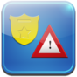
Client Management and/or Police Required - this icon is one of two "situation report" icons. If the duty officer finds signs of a break-in or damage to client premises upon arrival at the location he/she will action the icon by double tap, enter the location reference/job number in the pop up window, and press send. This response result report will appear on the ARC operators screen (along with the GPS location) and is also logged to the clients account history file.
Any activity following this particular report submission will depend on company operating procedures, the ARC operator may telephone certain persons to follow up, or the ARC system itself may be programmed to process this high priority signal and automaticly send other security units to the location to back up the officer on site.
NOTE! this icon may be used at any time whilst On Duty, it is not just for alarm response. A patrol officer doing rounds may come upon the scene of a break-in or find a client's window broken; the officer actions this icon, enters the particular client's account number and presses Send. This creates an event record and starts the process of follow up (and automatic officer backup if the ARC system is programmed for this facility) in regard the situation.

STATUS - The STATUS indicator clearly shows if the user is currently logged On Duty or is Off Duty

STATUS - double tapping the status indicator will bring up the Recent Activity Log, and User Activity Options, menu screen

Recent Activity Log
Alerts Received - select to show the last 25 alerts / user messages received
Reports Sent - select to show the last 25 reports logged to accounts / user messages sent
Event Actions - select to show the last 25 icon actions (for safety reasons silent Panic Alarm activations do not appear in the Event Actions log)
NOTE! Refer to the Event Actions log above when handling several different events, this will ensure you enter the correct response/customer reference number when sending situation or log reports.
User Activity Options
Send Message to User - click on the message button, enter the officer or Duty Task ID number you wish to send to, enter your message and press Send
(messages are restricted to 95 characters)
Routine Check In Reporting [ 60 minute ] suggested, change as required
GPS Location Reporting [ 5 minute ] suggested, change as required
Man Down Alert Active [ ] tick if you wish this feature to be active.
NOTE! if active, and the device tilts from the vertical by 70 degrees for 2 minutes - then a 90 second tone and vibrate device alert will commence
If after 90 seconds the No Further Action icon is not actioned, using current Duty Task ID number, to cancel the alert an alarm is issued to the ARC
An SMS advice may also be sent to the "SMS Out to - Number" if entered in user settings
CAUTION! the Man Down Alert facility should only be used where specific safety policies require special precautions
When the application is in duty mode i.e. status is On Duty, the application sends a GPS location report whenever an activity icon is actioned, as well as sending a GPS location report as per the timing set in GPS Logging Reporting. The application has been designed to conserve battery use and minimize telco data usage wherever possible, so the suggested settings provide a standard operating procedure for general application use. Higher risk duties would require increased regular Check-In and GPS location report intervals.

Guard Tour
24/7 Point Zero enables compatible NFC (Near Field Communication) equipped devices to act as a guard tour handset, capable of reading and reporting the details of specially coded tags. Patrol route / duty officers simply touch the back of their device (the NFC point) to a 24/7 Point Zero tag at any client location.
(users should ensure they have enabled NFC features in their device)
Upon tag data load a message will appear on the main screen advising successful tag read, the officer selects Send
and the details log direct to that particular client's guard tour history file in the ARC system.
NFC tags may be read by anyone with a suitable device; to ensure the integrity of 24/7 Point Zero guard tour read and report the application uses an internal algorithm upon tag read, this proprietary algorithm converts the basic tag data to a specific point signal record in the ARC's client file.
The guard tour function permits cross over of patrol routes and assistance from other duty officers in busy zones, no matter which officer actually performs the visit the tag detail report event will appear on the ARC operators screen and auto log to the specific locations guard tour history file.
Each guard tour log report includes the device identification of the officer recording the visit, the visit time, and as a further service verification procedure the GPS location of the device at that time.
Note! the ARC system may also be programmed to send automated reminder alerts direct to duty officers in the case of overdue or missed tour visit, this live interaction ensures a high level of customer service by providing remedial follow up during actual duty hours and before end of shift.

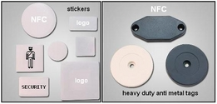

NFC stickers and hard tags may be encoded in house by ARC's and/or security companies.
Uses include guard tour, vehicle to officer logging record (staff record a tag read on vehicle issue at start of shift, detail is logged to the Duty Task ID history file) as well as technician on site record, tag/report upon arrival at a client location.

Activeguard Telematics Ltd

All Rights Reserved
This document may include or refer to products, logos, and/or trade names, of equipment or services provided by others.
Such reference is intended for information purposes only in relation to a users understanding of the application's operation.

