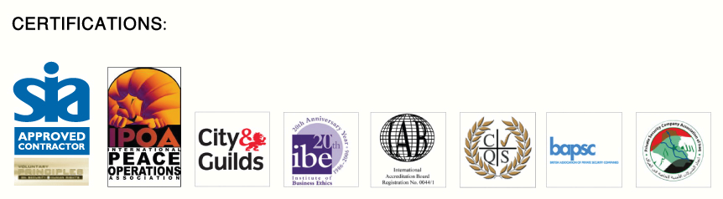
Why Scotia Group?
Our Understanding
Scotia Group is a global provider of integrated security and risk
mitigation solutions that enable governments, non-governmental
We understand risks to people, infrastructure,
business information, products / services,
and international organisations, and commercial customers to
processes and ultimately reputation.
assure high-value assets.
Scotia Group works in partnership with clients
to protect these assets in line with their
The company offers an array of security services and technology-
company ethos.
enabled solutions to support critical infrastructure protection,
Our People
post-conflict reconstruction, humanitarian work and emerging
We provide the most highly qualified individuals
market requirements.
from the Special Forces, Law Enforcement and
other specialist fields.
Scotia Group operates in over thirty countries with principal offices in
Our experience and skill allows clients to conduct
Port Harcourt / Nigeria, Dubai and UK.
business effectively in all corners of the world.
Our Expertise
From providing strategic consultancy to protecting individuals and
We can deploy assets promptly worldwide to
assets; developing complex security and crisis management plans
support our client’s needs and facilitate their
to driver training, Scotia Group has established a value chain of
project requirements.
products and offerings that has secured a diverse and impressive
Our office structure allows us to provide a local
range of clients.
insight on a global basis.
Our Diversity
We cover personal security, risk analysis,
security operations, logistics and business
The speed and apparent ease with
facilitation and training.
which
you implemented a successful
We offer a unique service for all security
requirements by providing our client’s with a
turnkey solution.
resolution against very tight deadlines
Our Response Time
was impressive by any standard... Scotia
Scotia Group is able to deploy its consultants
anywhere in the world quickly to support clients’
is an exceptional company with some
needs.
Scotia Group is also able to provide information
superlative individuals and is one of the
on a situation or area quickly and accurately.
This 24/7 service is a paramount in fast moving
premier security providers.
situations.
Our Reputation
Scotia is known for leadership, innovation and
being industry leaders for our holistic approach
-
FluorAMEC LLC
to security.
Our Ethics
Our reputation for integrity and unquestionable
ethical behaviour is reinforced by our Ethics
Committee.
Our Commitment
Our clients are our greatest assets and Scotia
Group is committed to providing the most
effective and reliable security operations.

Our Business
Global Experience
Consulting
Scotia Group's Consulting division provides clients with
solutions for Security Auditing, Business Continuity,
Emergency and Evacuation Strategies, Crisis
Management and Response, Kidnap and Extortion,
Contingency Planning, Strategic Infrastructure,
Defence Restructuring and Advisory services
to Governments.
Logistics and Project Support
Scotia Group provides clients operating in challenging
environments with services that range from the
construction of manned camps to the provision of life
support, the securing of mission critical equipment and
the emergency evacuation of employees.
Tracking and Locating Solutions
The SecureLocate™ service provides clients with a
unique tracking/locating cap ability for people, assets
and vehicles. The service, which can be monitored via
a secure web connection, can be overt or discreet and
is controlled through our 24/7 Control Centre with rapid

response teams deployed on the ground.

Scotia Group is ISO:9001

Integrated Protective Services

accredited and is
Scotia Group provides the full range of Security

Operations services, including Executive Protection,
dedicated to quality

Close Protection, House Detail, Key Point Security and
assurance.

Manned Guarding, Maritime Security, Asset Protection

(static and transit), Commercial and Residential

Security and Surveillance.

Intelligent Security & Safety Solutions

The scope of services and expertise offered by Scotia

Solutions
Group encompasses and exceeds the normal industry

offerings of CCTV, Access Control and Intruder

What we do

Detection. Services include Infrastructure Security,

Architecture Security Designs, Security Systems
Crisis Preparedness & Response

Design and Implementation, Project Management,
Critical Infrastructure Protection

Commissioning and Testing and the installation and

Emerging Market Entry Strategies

management of Command, Control, Communications,
Computer and Intelligence (C4i) Systems.
Integrated Security Solutions

Post-Conflict & Natural Disaster Recovery

Strategic Analysis & Assessment (SA2)

Security & Services
Scotia Group's Strategic Analysis & Assessment

division provides accurate, real-time information to

clients around the world, including 24/7 Security Alerts,

Country and bespoke Threat Assessments, Corporate

Strategy Reports and Strategic Security Analysis
Sectors

Reports for a wide range of sectors, for example Oil

and Gas. The Strategic Analysis & Assessment

Who we serve

service also includes Corporate Briefings,

Civil Engineering & Construction
Presentations and Telephone and Conference Call

Consultancy Support.
Organisations

Government & International Organisations
Training

Insurance & Financial Services
Scotia Group's training division offers Corporate

Security, Executive Awareness, Security Management,
Major Event Security
Counter-Surveillance, Counter-Kidnap and Crisis

Oil & Gas

Simulated Incident training. Scotia Group also owns and
Real Estate

operates a 700 acre training facility in Nesbit,

Transport (Air, Land, Sea)

Mississippi, which provides Military and Law

Enforcement, Basic, Special Forces, Explosive

Methods Of Entry and Weapons training.
We b: www. scotia com
Email : inf o@scotia-world com
© Copyright Scotia Group 2008. All rights reserved.

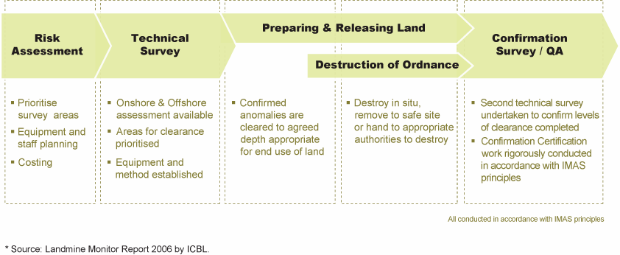
Appendix No 1 ( 1-2)
De-mining, Battle Area Clearance (BAC) and
Explosive Ordnance Disposal (EOD)
Landmines now affect over 78 countries world-wide, affecting millions of people and
Who is Scotia Group?
presenting a major obstacle to post-conflict re-construction and development efforts.
Scotia Group is a global provider
of integrated security and risk
De-mining is the process of removing landmines, booby traps and unexploded
mitigation solutions that enable
ordnance (UXO) so that contaminated land can be safely re-settled. In 2005,
governments, non-governmental
approximately 470,000 were removed. Every month over 1,500 people are killed or
and international organisations,
and commercial customers to
maimed by mine explosions.
assure high-value assets.
80% of casualties are civilians who are killed or injured after hostilities have
The company offers an
ended. Scotia Group has first hand experience of the human and commercial costs
array of security services and
technology-enabled solutions
of conflict and has developed a comprehensive de-mining capability led by a team
to support critical infrastructure
of experts.
protection, post-conflict
reconstruction, humanitarian
Our De-mining, BAC and EOD Services
work and emerging market
requirements.
For over three years Scotia Group has offered a commercially focused, bespoke,
Scotia Group operates in over
De-mining and EOD service which is specifically tailored to the needs of its
thirty countries with principal
individual clients.
offices in Port Harcourt - Nigeria,
UAE and UK..
Scotia Group recognises the challenges that international corporations,
governments, NGOs and aid agencies face finding suitable de-mining solutions. We
recognise that the safe destruction of unexploded ordnance is a humanitarian as
well as a business concern.
We offer strategic advice on clearance as well as provide clearly defined
deliverables which take into account a client’s time and/or budget constraints.
COMMERCIAL AND HUMANITARIAN DE-MINING
Why choose Scotia Group?
Commercial De-mining
Humanitarian De-mining
Conducted in accordance
With IMAS Standards.
Commercial and Humanitarian
De-mining Internationally
Recognised methodology
For de-mining sequencing.

Multiple methods of clearance,
Land and Underwater capabilities
Management and delivery of the
Entire process.

World class management team,
Integration of Local Staff via a
Comprehensive skills transfer
Process.

Provide own security Consulting
Services.

Stockpile destruction Work, to a
Pre-defined budget and time scales.

Recent experience in Conflict Zones.

Increasingly, many of our commercial
Scotia Group recognises that
r
clients find themselves working in
humanitarian de-mining requires a

remote uninhabited areas where there
slightly different approach in order to

is a threat from mines or other
ensure that a whole area is completely

unexploded ordnance. Scotia Group
safe for habitation. Scotia Group

offers a service which is entirely
combines de-mining services with mine

focused on meeting the needs of the
education programmes and other

client’s business, which is quantifiable
appropriate activities in order to enable

and measurable, bound by time, cost
communities to return to normal.

and performance parameters.

INTERNATIONALLY RECOGNISED METHODOLOGY FOR DEMINING SEQUENCING

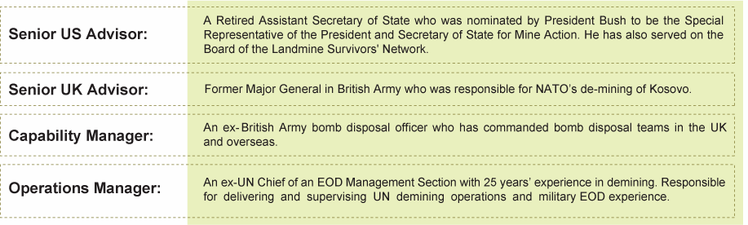
Appendix No 1 ( 2-2)
De-mining, Battle Area Clearance (BAC) and Explosive Ordnance Disposal (EOD)
MULTIPLE CLEARANCE OPERATIONS
Experienced de-miners operate in accordance with International Mine Action Standards
(IMAS) principles and use a number of clearance methods:
-
Manual Clearance
– including a wide variety of approved manual tools and electronic
detection devices.
-
Mechanically Assisted Clearance
– including flails and other mechanical devices.
-
Explosive Detection Dogs
– to support manual operations.
LAND AND UNDERWATER CAPABILITY
Where highly specialised de-mining skills are required, for example, underwater, Scotia Group
has selected world class partners to deliver the safest and most effective solutions for their
clients.
MANAGEMENT AND DELIVERY OF THE ENTIRE PROCESS
All de-mining projects are delivered in accordance with PRINCE2 methodology and clients are
assisted in all aspects of planning and managing their de-mining projects. Where appropriate
the conduct of de-mining operations is done within this framework. Scotia Group is also
accredited to ISO 9001:2000.
WORLD CLASS MANAGEMENT TEAM
INTEGRATION OF LOCAL STAFF
Scotia Group seeks every opportunity to integrate local communities into our de-mining and
EOD programs, therefore utilising local knowledge. With a comprehensive skills transfer
process we endeavour to train and deploy local staff.
ABILITY TO PROVIDE OWN SECURITY
Scotia Group supports
In hostile environments like Afghanistan and Iraq, Scotia Group has the ability to provide its
own security services. The integration of this crucial element into each team enables the safe
mobilization of the de-mining teams and secures clearances.
Scotia Group conforms
to International Mine Action
Standards (IMAS).
CONSULTING SERVICES
Scotia Group is
Olive Group is able to offer specific de-mining and related consulting services including:
ISO:9001:2000 accredited
and is dedicated to
quality assurance.
-
Weapons of Mass Effect (WME) Services -
highly specialist WME consulting services
offering organisations (from Governments down) advice on how to prepare for and
Scotia G RO UP SERVIC ES:
subsequently deal with the aftermath of a WME incident.
Consulting
De -mining
Integrated Protective Services
Intelligent Security & Safety Solutions
-
Procurement Advice -
specialist equipment advice and assistance with developing
Locating & Tracking
and analysing the clients needs.
Strategic Analysis & Assessment
T raining
© Copyright Scotia Group 2009 .
-
Battle Area Clearance
- specialist consulting and technical advice to inform clients of

priorities for clearance during post conflict reconstruction phases.

Appendix No 2 ( 1-2)
Integrated Protective Services
Understanding and managing the diverse range of risks to personnel, assets and data
Who is Scotia Group?
is fundamental to preserving corporate reputation and shareholder value. At Scotia we
Scotia Group is a global provider
advise clients on implementing cost effective, bespoke and integrated security solutions
of integrated security and risk
to mitigate or transfer risk exposure.
mitigation solutions that enable
governments, non-governmental
A company's success is underpinned by its assets, and protecting them in volatile and
and international organisations,
extreme environments is necessary to allow you to focus on your core business.
and commercial customers to
The diversity of business assets – from personnel and information to cargo – requires a
assure high-value assets.
holistic approach to asset protection.
The company offers an
array of security services and
At Scotia Group we provide a full range of Security Operation services including close
technology-enabled solutions
protection, asset protection and medical support, ensuring all risks are accounted for
to support critical infrastructure
and mitigated against.
protection, post-conflict
reconstruction, humanitarian
work and emerging
Each security operation package is designed and tailored for the individual client by our
market requirements.
dedicated security advisors whose experience has been perfected by extensive
operational presence in high risk environments.

Our project managers are permanent employees of Scotia Group, hand picked by the

Group’s Director of Operations. All are formerly Warrant Officers from UK Special
Forces. Scotia Group’s security consultants must have a minimum of 10 years
experience in military or law enforcement and hold an industry-approved close
protection qualification. Scotia Group’s security operators are dedicated to providing the
highest operating standards in the industry, thus creating a benchmark for others.
The pursuit of excellence and highest disciplinary standards are what every Scotia
Group employee must strive to maintain.
Our consultants possess extensive regional and operational experience having
Why choose Scotia Group?
operated in Iraq, Afghanistan and other high risk countries around the world.
Each security operation is
Our teams of international staff, combined with local security professionals and support
designed and tailored for the
staff ensure local customs and regulations are adhered to. This mix ensures best
individual client
practice, by combining local knowledge and insight with international standards. This
Security operations are project
re-enforces our dedication to providing the highest operating standards in the industry.
managed by former members
of Special Forces from the
SCOPE OF SERVICES
United Kingdom, South Africa,
Australia and New Zealand
Executive Protection: Scotia Group utilizes the expertise of former UK Special Forces
Ongoing operational presence
and Royal Military Police Close Protection Operators to provide tailored, specialist
in high risk environments such
executive protection to diplomats, non-governmental organisations, CEO's, and high
as Iraq, since 2003
net worth individuals. Scotia Group prides itself on the professionalism of its close
Combination of operational
protection operators who are mindful of the profile of their clients and when they
planning, personnel provision
and logistical support.
themselves need to be high or low profile.
Hostile Environment Close Protection: Scotia Group conducts close protection in
some of the worlds most hostile and remote environments, including Iraq and
Afghanistan. We provide bespoke planning and implementation including the
provision of armed security, life support services, command and control solutions and
armoured vehicles. Our services are ready to be deployed in times of international
crisis whether through internal security issues, post regime change where the rule of
law has failed or through natural disaster. Scotia Group assisted in relief efforts in
Indonesia following the tsunami and in the US, post - hurricane Katrina.
Key Point Security: Using proven threat and risk methodology combined with a
wealth of experience, Scotia Group can identify and counter risks. We provide
effective key point security plans and ensure implementation and management are
carried out. From corporate headquarters to strategic power plants, Scotia Group can
provide the right level of manpower and technology to protect facilities in a cost
effective manner.

Appendix No 2 ( 2-2)
Integrated Protective Services
Recent Projects
Protective security and
management for oil and gas
facilities and pipeline projects
in central Asia, Latin America
and the Middle East
Convoy escort and personnel
protection in the Middle
East for commercial and
government clients
Airport facility security review,
guard force, supervision and
air marshalling task in the
Middle east for high value
cargo
Perimeter security and
access control advisory and
management teams working
with the Iraq Ministry of
Defence and Iraqi Ministry
of Interior
Compound security and
ammunition convoy escort
in Afghanistan
Maritime Security: Scotia Group has extensive knowledge and experience in the
field of maritime security with past performance of port security management and
ISPS accreditation management and implementation. Scotia Group can provide
Maritime contingency planning, vessel security (on board or port facility), Maritime
Counter Terrorist advice and tracking of maritime assets.
Asset Protection: Scotia Group has a wealth of experience in the field of asset
protection, from escorting high value cargo in transit to safeguarding specialised
high value equipment on static locations. All client requirements are taken into
account and a robust security posture implemented to ensure integrity of the assets
wherever they may be.
Commercial and Residential Security: Scotia Group has a proven past performance
not only providing protection to commercial and residential properties but also to
NGO and government compounds and facilities around the world. Scotia Group can
provide patrolling guards and access control supervisors where needed, coupled
with systems design and technology where appropriate.
Surveillance: Scotia Group has a proven covert surveillance capability, and can
deploy teams at short notice to conduct foot or mobile surveillance in urban or rural
environments. Using experienced operators and state of the art technical
surveillance equipment, Scotia Group can covertly collate intelligence, or can turn
the tables to conduct effective counter surveillance measures.
Medical Support: Scotia Group has integrated UK Special Forces paramedics within
its security teams who are advance trauma qualified. They are authorized to carry
controlled drugs for pain relief and to stabilize casualties for evacuation. Scotia
SCOTIA G RO UP SERVI CES:
Group medics can also run courses for clients and dependents at remote worksites
Consulting
De-mining
or within accommodation compounds.
Integrated Protective Services
Intelligent Security & Safety Solutions
Loca ting & Tra cking
Stra te gic Ana lysis & Assessmen t
Tra ini ng
© Copyrigh t Scotia Grou p 200 8.
A ll r ig ht s r e s er v ed .
Fo r mo re inf orma ti on:
www. Scotia-World. com or inf o@scotia-world.com. com

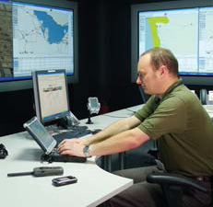
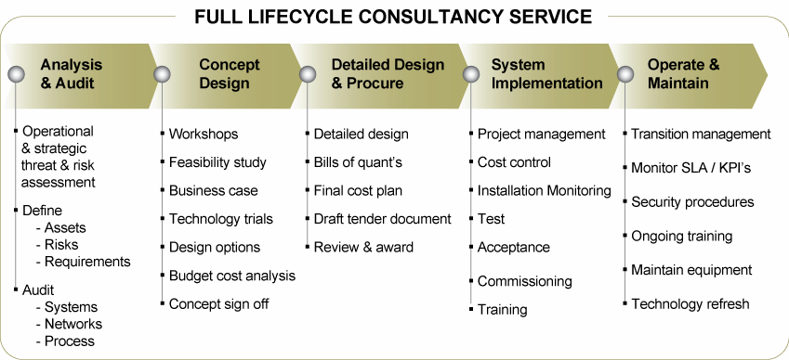
Appendix Number 3 (1-2).
Intelligent Security & Safety Solutions
Understanding and managing the diverse range of risks to personnel, assets and data
Who is Scotia Group?
is fundamental to preserving corporate reputation and shareholder value. At Scotia we
Scotia Group is a global provider
advise clients on implementing cost effective, bespoke and integrated security solutions
of integrated security and risk
to mitigate or transfer risk exposure.
mitigation solutions that enable
governments, non-governmental
Scotia Group specialises in servicing the following markets and types of projects:
and international organisations,
and commercial customers to
assure high-value assets.
SERVICES AND EXPERTISE
The company offers an
array of security services and
technology-enabled solutions
Property and infrastructure security
– strategic and operational threat and risk
to support critical infrastructure
assessments, security and access control systems, area wide cordon and ring of steel
protection, post-conflict
networks, intelligent building systems, telecommunication systems, intelligent visual
reconstruction, humanitarian
systems, intelligent ID cards and business process analysis.
work and emerging
market requirements.
Intelligent transportation systems
– intelligent road, rail, air and maritime systems
Scotia Group operates in over
including vehicle monitoring and classification, RFID tagging, journey time
thirty countries with principal
management, tolling & charging, number plate and other vehicle and visual recognition
offices in Dubai, and UK.
and control centres and data and disaster recovery centres.
Telecommunications networks
– fixed, wireless, WiFi, WiMax, Mesh and IP
networks for deployment across various platforms and including the transmission of
voice, data and images.
Data and Image centres
– local and national command and control centres with data
capture and mining capabilities including resilience, disaster recovery, and business
continuity measures.
Olive Group’s in-house Intelligent Security and Safety Solutions division offers a
technology driven full lifecycle consultancy service from feasibility project delivery
to operational support. For clients needing to build and operate sophisticated
security systems we help turn complex projects into reality by offering a turnkey
Why choose Scotia Group?
service from initial inception to full implementation.
End to end solutions -
from feasibility and design
to procurement and
implementation
Supplier independent solutions
Integrated solutions where
leading edge technology is
combined with effective
operational management
business processes
Innovative and forward thinking
Highly skilled staff with
experience in all market
sectors on a international basis
History of proven and
successful project delivery
This enables us to address security, safety and technology issues and offer
integrated solutions where leading edge technology is combined with effective
operational management business processes.

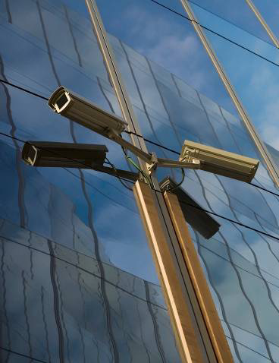
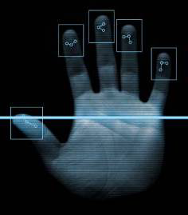
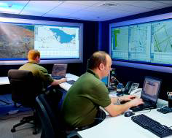
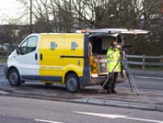
Appendix Number 3 (2-2).
Intelligent Security & Safety Solutions
STRATEGIC SECURITY AND RISK MANAGEMENT ADVICE
Scotia Group offers bespoke strategic security and risk management advice in order to
protect critical assets including people, business information, infrastructure, products &
services and processes to brand reputation. We offer:
Risk and Vulnerability Analysis
– assessing the full spectrum of risks and
recommending measures to mitigate against them
Threat Assessments
(Criminal, Terrorist, Protestors & Activists, Saboteurs &
Subversives and Natural Disasters) – strategic, operational and tactical assessments
identifying & defining the current threat and assets and assessing the client’s exposure.
Architecture Design Review
– A complete review of the internal and external building
design is essential when ensuring that key security requirements are incorporated into
the building at the earliest, and therefore, the most cost effective time.
Sector Experience:
Business Impact Appraisal
– thorough analysis of the risks may identify potential
threats that could be avoided or eliminated by early consideration
Real estate developers
- Commercial
Our team follow tried, tested and proven methodology to conduct high quality risk
- Residential
Assessments. We tailor each assessment to the client’s needs and work with them to
- Retail
identify the risks and ascertain their risk posture. Our comprehensive reports provide
- Hotel & leisure
In-depth detail of the risk itself, an d highlight the appropriate strategies for the
Organisation’s team.
Transport authorities
- Road
- Rail
- Maritime
LEADING EDGE TECHNOLOGY
- Air
Our experienced and qualified design staff deliver supplier independent, innovative,
Communications providers
‘best of breed’ solutions that are relevant and value for money, drawn from the
Oil & Gas companies
latest technology on the market.
Government
The areas of technology that we specialise in are:
Police authorities
CCTV and surveillance systems
We have gained unrivalled
Intelligent visual systems & software
knowledge over the years,
working with a wide variety
Access control systems
of high profile organisations
on an international basis.
Intruder detection systems
Perimeter Intrusion and fencing systems
Biometric systems
Number plate reading systems
Intelligent parking systems
Screening solutions (vehicles, people, objects)
Guard tour systems
Ballistic protection
Bio hazard detection
Digital and analogue recording systems
Control Rooms (interface and integration)
Asset & RFID tagging systems
SCOTIA G RO UP SERVI CES:
Consulting
Communications networks
De-mining
Integrated Protective Services
Intelligent Security & Safety Solutions
Locating & Tracking
Strategic Analysis & Assessment
Training
© Copyright Scotia Group 200 8.
All rights reserved .
For more information:
www. Scotia-world. com or inf o@scotia-world. com

Appendix Number 4 (1).
Life Support Solutions
The Scotia Group Life Support Unit provides comprehensive life support solutions in
Who is Scotia Group?
the most extreme conditions, allowing you to focus on your core business. Life
Scotia Group is a global provider
Support Solutions include consulting services, temporary housing, general and
of integrated security and risk
specialist maintenance, food supply and catering, camp servicing and management,
mitigation solutions that enable
sea/land/air transportation and escort, equipment sourcing and shipping, and
governments, non-governmental
security. Scotia Group integrates internal and external resources to provide a one stop
and international organisations,
and commercial customers to
shop solution.
assure high-value assets.
EXPERTISE IN EXTREME ENVIRONMENTS
The company offers an array
of security services and
technology-enabled solutions
Since 2003, Scotia Group has provided life support services for corporate and
to support critical infrastructure
government clients in Iraq and Afghanistan, in Mississippi after Hurricane Katrina and
protection, post-conflict reconstruction,
in post-tsunami Indonesia.
humanitarian work and emerging
market requirements.
SCOPE OF SERVICES
Scotia Group operates in over thirty
countries with principal offices in
Offering life support in extreme environments is challenging even for companies with
Port Harcourt – Nigeria, UAE & UK..
experience in operating in difficult areas. Scotia Group offers an integrated solution
Why choose Scotia Group?
including technical sourcing and logistics capabilities, as well as deploying a wide
range of expertise in the most extreme environments.
Successful history of providing life
support integrated solutions in the
most challenging environments.
SERVICES
Integrated solutions - including
security and consulting services.
Temporary housing solutions
Camp servicing and management
Full service offering from temporary
housing solutions, general and
Safe houses, camp design and
Reception management, cleaning, garbage
specialist maintenance, utility
construction, tents, pre-fabricated and
removal, sewage management, fuel supply
and fuel supply, food and
containerized accommodation, kitchen
and point of distribution management,
catering, transportation to
and leisure facilities, water and power
health care and sanitary evacuation.
camp management.
supply, garbage and sewage facilities.
Transportation and escort
Why an integrated solution?
General and specialist maintenance
Fixed or rotary wing, sea and land
Generators, general electricity and
transportation of cargo and personnel, hard
When security is a key success factor
to your operation, then an integrated
carpentry, reefers, kitchen equipment,
and soft skin vehicle rental.
solution helps you mitigate risks and
soft and hard skin vehicles.
focus on your core business:
Additional Services
Food supply and catering
IT and communication solutions (voice and
This reduces your exposure to risk
Food procurement from local or domestic
data), office related services and technical
as we manage the pre-deployment
markets, shipping and catering.
sourcing.
and deployment phases, you may
even consider operating in an area
you previously excluded because of
the risk level.
INTEGRATED SOLUTIONS
We integrate internal and external
resources, so that you have only one
Security, Consulting, Tracking and Locating Solutions
point of contact. You decrease your
Life Support Solutions are thoroughly integrated with other areas of our business
mobilization costs and reduce your
expatriate staff to the minimum.
which include:
security services which can ensure that personnel, and other assets reach
their destination safely,
advanced tracking and locating solutions with managed response, and risk

alert capability,

a consulting division to provide pre-deployment, research, risk assessments,

business feasibility and due diligence.

Appendix Number 5 (1-2).
Locating and Tracking Solutions
Who is Scotia Group?
Scotia Group is a global provider
of integrated security and risk
mitigation solutions that enable
governments, non-governmental
and international organisations,
Ensuring the safety of critical assets, whether personnel, information, equipment or
and commercial customers to
cargo, is key to success in today’s business environment. Loss or damage of any one
assure high-value assets.
of these can have serious implications for an organisation’s operational continuity. Scotia
Group can help clients protect and monitor essential assets through its integrated
The company offers an
array of security services and
tracking system, SecureLocate™.
technology-enabled solutions
to support critical infrastructure
Building on proprietary software, Scotia Group’s dedicated research and development
protection, post-conflict
team can ensure that the tracking capability provides adequate protection for
reconstruction, humanitarian
work and emerging
employees and assets without infringing on the client’s operational capability.
market requirements.
As well as offering standard tracking, locating and alarming capability, Scotia Group can
Scotia Group operates in over
provide hardware (including GSM cell phones with built-in tracking device and panic
thirty countries with principal
offices in Port Harcourt - Nigeria
button), software, installation and training, and primary monitoring from Scotia Group’s
UAE and UK.
24/7 Operation Centre.
SecureLocate™ feeds can also be integrated into Google Earth, allowing clients to
Why choose Scotia Group?
easily track their assets on screen and make sense of their movements. Additionally,
Highly innovative research
Scotia Group can provide real time threat and risk information to clients through the
and development team.
SecureLocate™ system ensuring that high risk areas can be ring-fenced ‘out of
Provide customer focused
bounds’ and assets diverted if necessary.
solutions tailored to specific
requirements.
In certain operating environments, Scotia Group can also offer a bespoke
End-to-end solutions
SecureLocate™ Response Team, delivering a comprehensive alert and response
include hardware, software,
capability in an emergency.
installation, integration with
Google Earth, client and
operator training, additional
SecureLocate™ solutions can be used in a wide range of situations, including:
intelligence data feeds and
primary monitoring 24/7
Fleet management
from the Control Centre.
Aviation and maritime tracking
Convoy security
Static alarms / panic alarms
Immediate employee and asset location in the event of a serious incident
Scotia Group’s ownership of the SecureLocate™ source code, combined with its
integrated system offering ensures client requirements can be covered from hardware
provision through to asset recovery.
EXPANDING YOUR SECURE ENVIRONMENT
SecureLocate™ uses both GSM and high sensitivity GPS networks to provide precise
location information. The monitoring system is web-based, allowing clients to track
their assets’ location through a secure server even when on the move themselves.
Equally, asset monitoring and alarm response can also be outsourced to the Scotia
Group 24/7 Control Centre, where a dedicated team can provide advice and ensure
appropriate responses are in place to recover assets following an incident.
SecureLocate™ mapping and data are constantly updated to provide the most
accurate information available.

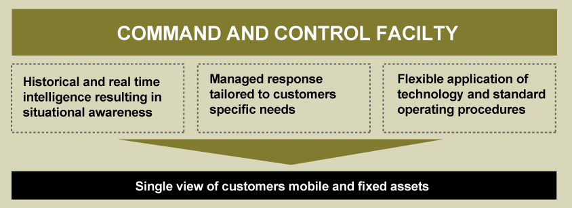
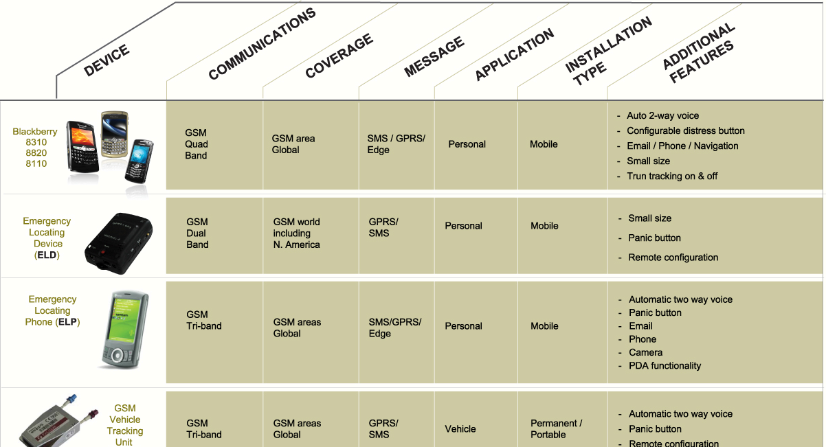
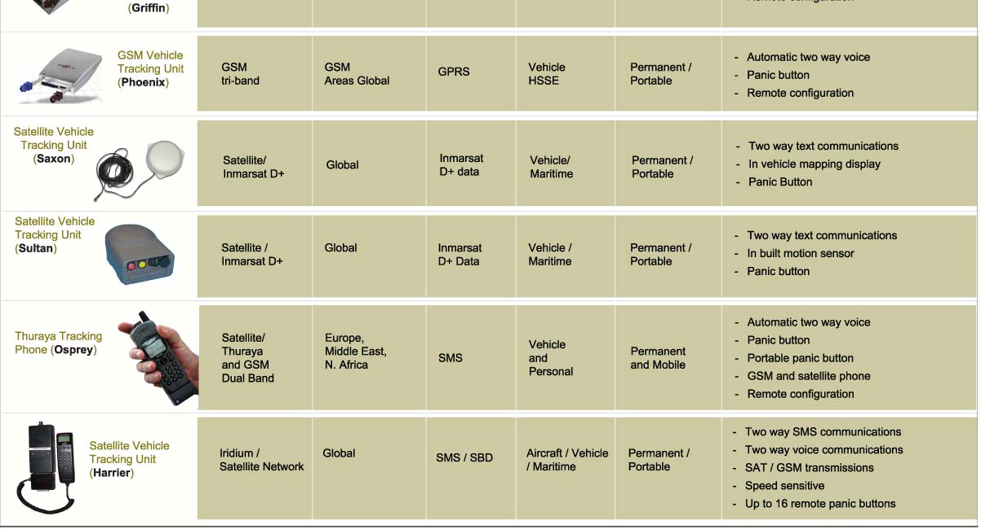
Appendix Number 5 (2-2).
Locating and Tracking Solutions
How Does it Work?
Pressing the alarm on a
SecureLocate™ device triggers
an alert/display either in the Scotia
Group Control Centre, on an
authorised laptop or authorised
mobile phone. Location
information is reported and
one or two-way GSM voice
communications are opened,
enabling the 24/7 Control Centre
to either discreetly ascertain the
nature of the problem (e.g. in
case of kidnap) or to talk directly
to the respondent (eg in case
of
LOCATION AND TRACKING DEVICES
remote location road traffic
accident). Scotia Group and/or
Scotia Group will work with the clients to ensure the correct form of tracking device is
the client can then respond in
the pre-arranged manner.
used and can provide an extensive variety of tracking hardware. Devices can either
Using the SecureLocate™
be set to track constantly, provide intermittent tracking, or only be used to pinpoint an
system ensures that:
asset’s location in the event of an incident or emergency.
Appropriate and timely
assistance can be provided in
the event of an incident. This
can range from receiving
instructions by phone to the
deployment of a Rapid
Reaction Team (RRT).
Available intelligence
information can be used
proactively to advise personnel
of risk.
Detailed and proven SOP’s
formulated by a team of
ex-military officers ensures
the highest quality of support.

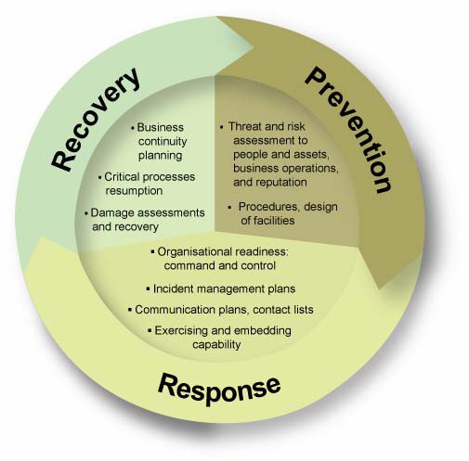
Appendix Number 6 (1 -3).
Strategic Advisory Services
Scotia Group’s Consulting division provides strategic advisory services to support
governments, quasi-government organisations, industry and individuals to
Who is Scotia Group?
understand and manage their key risks. Our services are aimed at protecting our
clients’ highest value assets. Focusing at the senior decision-making level, we
Scotia Group is a global provider
of integrated security and risk
enable our clients to understand their critical risks, identify priorities, and make
mitigation solutions that enable
informed choices about where to invest resources to manage and reduce those
governments, non-governmental
risks. Equally, we enable them to identify and take advantage of opportunities that
and international organisations,
can create competitive advantage.
and commercial customers to
assure high-value assets.
Scotia Group has a breadth of experience advising and supporting clients at the
The company offers an
highest levels of government and the corporate sector in the areas of security
array of security services and
strategy, crisis management, and new market entry. Our capability is built on
technology-enabled solutions
to support critical infrastructure
operational experience in high risk environments and senior level expertise in the
protection, post-conflict
areas of national security, defence sector reform, and technology-enabled critical
reconstruction, humanitarian
infrastructure protection.
work and emerging market
requirements.
CORE AREAS OF OUR WORK ARE:
Scotia Group operates in over
thirty countries with principal
Crisis Management Strategy and Planning
offices in Port Harcourt - Nigeria
UAE and UK.
We provide end-to-end support to governments and industries in crisis
management. Our starting point is to examine existing capability for crisis
Why Choose Scotia Group?
preparedness, with a view to improving what may exist to meet current and future
challenges. Our perspective is strategic, addressing the full spectrum from
Breadth of Capability
Crisis management strategy
prevention to response and recovery. Improving prevention planning through a
and planning
robust threat and risk assessment and strengthening procedures that would reduce
National security and resilience
risks of untoward incidents is critical. Effective response mechanisms can make all
Major events security
the difference between a well managed incident and a disaster. We help our clients
Critical infrastructure protection
Market entry support
to develop effective organisational systems, well trained personnel, and specific
plans for managing incidents such as natural disasters, pandemics, or terrorism.
Unique expertise
Security and defence
Scotia Group’s commitment goes well beyond delivering a crisis management plan.
sector reform
Governments, oil and gas,
We support our clients in implementing the plan, through a range of activities
construction, and infrastructure
including:
industries
Due diligence
Exercises and scenario
Operational experience in high
planning to build organisational
risk environments
readiness
End-to-end solutions
From strategic planning to
Bespoke threat and risk
implementation support
assessments on specific
Organisational readiness
locations or scenarios
Threat and risk assessment
Tracking
Asset and people tracking
Technology-enabled security
solutions through our 24/7
systems design
Logistics and security support
control centre
Enhancement of physical
security of facilities through
intelligent and cost-effective
use of technology
Operational support and
security in the event of
evacuation

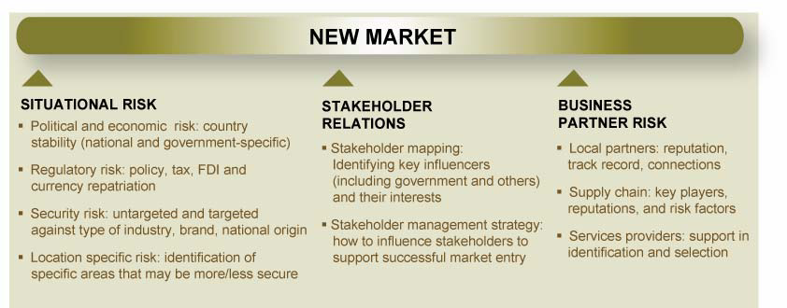
Appendix Number 6 (2-3).
Strategic Advisory Services
Security Strategy
We enable governments to identify their current and future national security risks,
assess capabilities, and develop solutions to manage risks. Areas of our work
include national security, critical infrastructure protection, and major events
security. Our work with industry focuses on corporate security policy, interface
with government bodies, and crisis management planning.
We help our clients to address the following type of questions:
What should security priorities be in the immediate and longer term?
Are existing mechanisms for threat and risk assessment and integrated
response capable of meeting future needs?
Where should investment in improved processes and critical infrastructure
protection be focused?
Building on the decisions that result from this, Scotia Group is able to support
clients in taking good ideas into effective implementation through its capabilities
in providing integrated security solutions.
Market Entry Support
New market entry can be a daunting challenge for many companies. Scotia can
help clients understand and manage the risks involved to enable them to take
advantage of the market opportunity. We help clients understand and take steps
to mitigate three types of risk factors involved in new markets:
Situational risk, focused on political, regulatory and security issues
Business partner risk, focused on understanding who our clients may need to
work with
Stakeholder relations risk, focused on identifying and building relations with
key influencers
Scotia Group utilises its deep experience in certain countries and partners with
other select high-quality providers to enable market entry in a range of countries
across the Middle East, South Asia, North Africa and West Africa. Our work
dovetails into implementation support as per clients needs.
Turnkey Market Entry Solutions

Appendix Number 6 (3-3).
Strategic Analysis and Assessment
The core competency of Scotia Group’s Strategic Analysis and Assessment (SA2)
Who is Scotia Group?
division is the creation of networks that collect, analyse and disseminate information.
SA2 helps clients make timely, well informed decisions that can enable business by
Scotia Group is a global provider
reducing risks and facilitating business continuity. All SA2 services function in
of integrated security and risk
support of the client’s core business objectives through the provision of intelligence
mitigation solutions that enable
governments, non-governmental
to pursue competitive advantage, demonstrate duty of care, mitigate risk and
and international organizations,
assure business continuity.
and commercial customers to
assure high-value assets.
Unlike providers of ‘generic’ information services, SA2 holds workshops with clients
The company offers an
to understand exactly their unique footprint, threat profile, risk tolerance and
array of security services and
reporting requirements, and to design their own intelligence support retainer using
technology-enabled solutions
a bespoke combination of the below services.
to support critical infrastructure
protection, post-conflict
reconstruction, humanitarian
Extensive use is made of cutting-edge incident databases and advanced mapping
work and emerging
techniques to quantitatively analyze and visualize the threats that are directly
market requirements.
relevant to the user, no matter how volatile the location.
Scotia Group operates in over
thirty countries with principal
On-the-ground sourcing is the cornerstone of SA2’s collection capabilities. Direct
offices in Port Harcourt - Nigeria
access to SA2’s analysts is another important part of Scotia Group’s intelligence
UAE and UK.
offerings. Intelligence support services are delivered to the points-of-contact
defined by the client using the means of dissemination (SMS, email, verbal
Why choose Scotia Group?
briefings) that the users deem most effective.
As a well respected and highly
professional international
SA2SERVICES
provider of total security
solutions Scotia Group provides
comprehensive intelligence
Watchkeeper 24i
Data Mapping
services
Decision Support Tools
support based on any security
needs.
delivers a 24/7 SMS
allow layers of tactical
are Scotia Group’s unique
security alert service on
data to be displayed and
metrics-based risk
As a boutique information
security-critical events
configured to client
monitoring service. Users
provider the A2 division
through the
specifications on a highly
define a set of benchmarks
specializes in the design and
Control Centre, using a
secure d satellite imagery
that will trigger market
delivery of bespoke reporting
special team of
mapping platform. Users
entry, evacuation or a
systems.
experienced A2 analysts.
can visualize their
change in security posture.
Clients also receive
operating locations and
Scotia Group monitors the
The A2 division has a high-
calibre analyst team which
authoritative "post
personnel in real-time to
situation at key locations on
benefits from exploitation of
incident analyses" to
support pre-entry project
the ground and warns when
Scotia’s operational footprint
advise on how major
planning plus crisis and
risk levels re ach the user’s
and support from a robust
security events may
incident management.
specified levels.
Expert Network.
impact their business and
personnel.
A2 reporting is enabled by both
human intelligence and
advanced technology. The
Commissioned Reports
Environmental
Executive Briefings
give
24/7 Control Centre
serves as the fusion point for
Scanning
uses website,
result when users task our
senior decision-makers
our Security Operations,
media and public opinion
expert team to report on
the access to regular and
Intelligence, Tracking and
single issues of very
sampling to scan for
ad hoc briefings by Olive’s
Emergency Response
hostile intentions and
specific and highly
authoritative experts across
surveillance, plus risks to
confidential interest to their
the full range of threat and
market entry, reputation

business. Using on-the-
risk issues. The service

and intellectual property.
ground sources, A2 can drill
is confidential, flexible,

down into local security and
A surprising number of
interactive and completely

threats and indicators are
political dynamics. Verbal
bespoke to requirements.

visible for those who
briefings can be arranged
Briefings can be targeted

either in conjunction with
know where to look.
at board- level decision-

commissioned reports, or
makers, security

as a stand-alone service.
management, or even

expatriate personnel
and families.

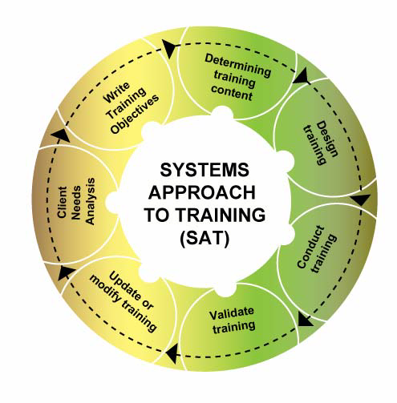
Appendix Number 7 (1-2).
Training
An organisation’s success is underpinned by its people ensuring they are
Who is Scotia Group?
effectively trained to operate in volatile or high risk environments is critical. Scotia
Scotia Group is a global provider
Group believes training is an essential element of both capability and duty of care.
of integrated security and risk
This drives our approach and ensures that we work with our clients to provide the
mitigation solutions that enable
highest quality and most relevant training for their needs.
governments, non-governmental
and international organisations,
and commercial customers to
Scotia Group offers bespoke training solutions for corporations, executives, NGOs,
assure high-value assets.
governments and emergency services, as well as military and law enforcement
personnel. Courses are taught by highly experienced trainers, a majority of whom
The company offers an
are former Special Forces Instructors. Scotia Group trainers combine current
array of security services and
technology-enabled solutions
methodology with contemporary operational experience and courses are
to support critical infrastructure
continually reviewed and updated to ensure their relevance and adherence to
protection, post-conflict
standards of best practice.
reconstruction, humanitarian
work and emerging
market requirements.
Scotia Group offers over 70 courses, including;

Close Protection
Emergency Response

Security Management

Health and Safety

Driving Courses
Fire Safety
Firearms
Scotia Group’s US training facilities
unparalleled experience, complete with live fire capability for anyone working in
very high risk environments. In addition to the US training base, Scotia Group also
provides peripatetic training teams which can deliver courses at locations
convenient to the client’s centre of operations.
Why choose Scotia Group?
CUSTOMER FOCUSED SOLUTIONS
End to end solutions -
from feasibility and design
to procurement and
Rather than provide generic courses, Scotia Group works in close consultation with
implementation
clients to determine their exact training or learning requirements. This enables us to
design the courses or products which will be of most benefit and value to the client,
Customer focused solutions
tailored to specific
potentially providing time and cost savings, while delivering an optimum service.
requirements
INSTRUCTORS WITH
World class training facility
CONTEMPORARY OPERATIONAL
in the US, with multiple
driver training tracks and
EXPERIENCE
live fire ranges
Scotia Group instructors are experts in
Experts tuition from former
their fields, and are recruited from the
UK Special Forces instructors
UK Special Forces or UK Emergency
Guaranteed to deliver on
Fire and Rescue services. Their
time and budget to the
teaching expertise is underpinned by
highest standard
contemporary operational experience in
Training consultancy and
a range of challenging environments
mentoring capability
enabling them to give clients relevant,
realistic and potentially life saving
instruction.
CONDUCTED USING THE SYSTEMS
APPROACH TO TRAINING (SAT)
Scotia Group employs SAT – the benchmark training methodology – at all levels of
its training programmes.

Appendix Number 7 (2-2).
Training
MANAGEMENT AND DELIVERY OF THE ENTIRE PROCESS
Scotia Group can provide complete turnkey integrated solutions to meet clients’
training needs. The group also employs project management methodology to ensure
that services are delivered on time, to the agreed standard and at the agreed price.
Outsourcing training requirements to Scotia allows clients to focus on what really
matters to them, and to benefit from a better informed and equipped workforce.
TRAINING CONSULTANCY
If clients are formulating their own training strategy and requirements, Scotia Group
offers a Training Consultancy service to advise, guide and mentor.
SCOTIA GROUP TRAINING FACILITIES
Scotia Group is continuing to develop its Memphis-located Scotia Security Training
Centre (OSTC). OSTC currently offers state of the art training facilities, including a driver
training circuit, an off road driving circuit, live fire weapons and explosives ranges, as well
as fully equipped training rooms and an extensive fleet of practice vehicles.

